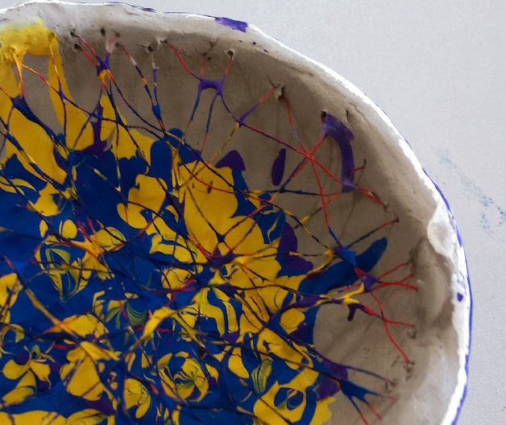

**Art Therapy brings Peace of Mind.**

**Art Therapy is not just for kid and artists.**

**Contact me:-**

**Janinemoffatarttherapist@yahoo.com**

**Arttherapyandhealthyminds.com**

**My Background?**

I have considerable experience working with children, adolescents, and adults working on a one to one art psychotherapy intervention or groups for art psychotherapy.

Art Therapy has been a way for me to combine my experience and interest in both mental health and art making, to improve and enhance the physical, mental, and emotional well-being of individuals of all ages, from any background.

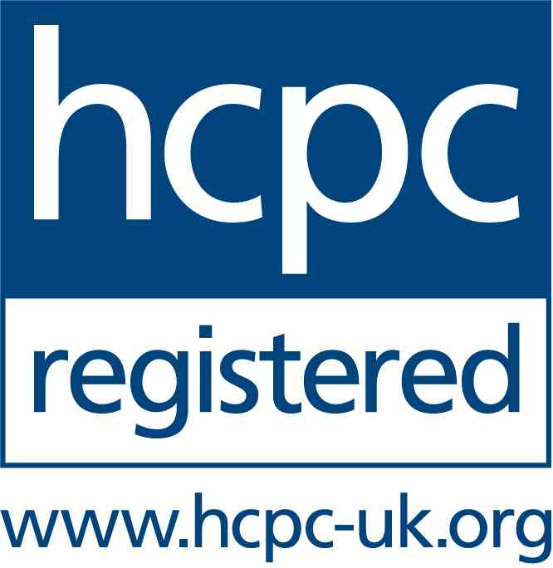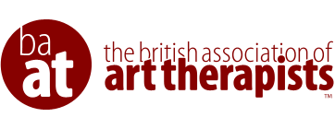

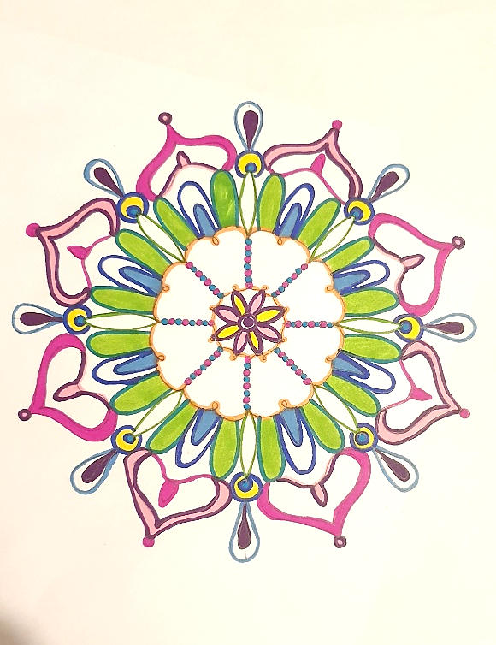

**Who is it for?**

Art Therapy is for anyone who struggles to understand their emotions and feelings.

Who may have experienced some form of loss, grief, abuse, attachment issues, or trauma, and feels that they may need a way of understanding it all, but words either don't seem to be enough or can be too much.

**How Can Art Therapy Help You?**

* Providing a safe and confidential space to express yourself freely.
* It can help you to understand and express emotions or feelings that might be too difficult to hold, and could help you transform these feelings into more comfortable ones
* Art therapy can help you explore situations and parts of yourself you might not understand.
* You can create and share what you want, you do not have to be ‘good’ as we see it as a safe space free for expression and curiosity, with no judgement.

**Art Therapy**

**With Janine**

“I am my own muse; I am the subject I know best.

The subject I want to know better.” – Frida Kahlo

**What is Art Therapy?**

Art therapy is a form of therapy where feelings and emotions can be explored through using painting, drawing and any other form of art making. It is a process we can use when words are not enough.

The Sessions can take place in person in Coatbridge LCCC (Lanarkshire Counselling & CBT Centre) or Online. The cost of the 50 minute therapy sessions is £50 with an initial assessment session.

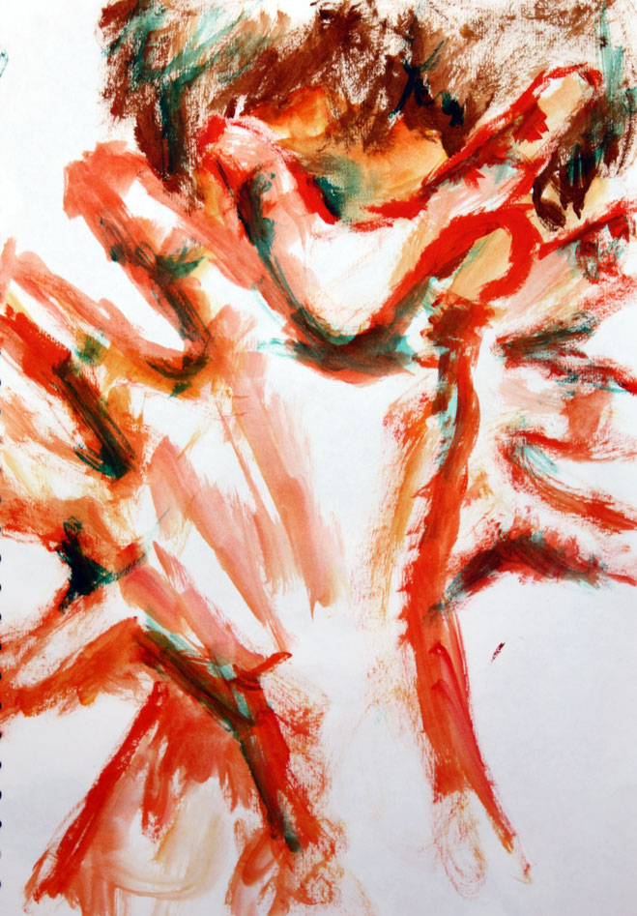

Confidentiality is very important in Art therapy, which would be discussed with the client and if under 16 years their guardian.

Consent will be asked from the client and their guardian (under 16) regarding confidentiality and the agreed contracted art therapy sessions.

The therapist has a supervisor to make sure you are given the best service possible.

**Confidentiality**